Leases and SBITAs GL Journal Entries

Objective: The objective of this file is to provide detailed instructions to state agencies and component units (except MUS and MSF) on how to calculate and record GL entries for leases and SBITAs. Throughout the rest of this instruction, where it references leases, it is also applicable to SBITAs.

Background: When agencies record leases in SABHRS, it is added to the Lease Administration module (LA) and the lease entries will be generated in the Asset Management module (AM), including new lease addition (ADD), monthly amortization (DPR or PDP), and principal reduction (LPY or PLP). If agencies retire leases in SABHRS, AM will generate accounting entries as RET entries. Certain GL entries are required to make the GL account balances correct. Below will show the steps and GL journal entries that agencies need to prepare for each lease stage. The example lease was commenced on 7/1/2024.

Adding a new lease: When agencies add a new lease to LA, AM will generate ADD entries to increase (debit) lease assets 183x or SBITA assets 184x (initial direct costs plus lease payments at or prior to lease commencement plus present value of future payments measured at commencement date) and increase (credit) lease liability 2104B or SBITA liability 2104F (just the present value of future payments measured at commencement date) and sometimes credit 69502 for the payment scheduled at lease commencement or any initial direct costs. If the amount in 69502 in the ADD journal is for the initial direct costs, the portion for the initial direct costs should be reclassified to 63413 NB Lease Offset – AM. If the amount in 69502 in the ADD journal is just the first lease payment scheduled on the commencement date, no reclassification for 69502.

The use of a ledger depends on the fund type (ENTITYWIDE ledger for governmental fund or ACTUALS ledger for proprietary fund.
Fund | Account | Account Description | Debit | Credit | Explanation
01100 | 1832 | Intangible Right to Use Bldg | 309,146.66 |  | Addition of lease asset for the present value of future lease payments
01100 | 2104B | Standard Lease |  | 309,146.66 | Addition of lease liability for the present value of future lease payments
01100 | 1832 | Intangible Right to Use Bldg | 6,027.75 |  | Addition of lease asset for the first lease payment scheduled at the commencement date
01100 | 69502 | NB ROU Lease Principal |  | 6,027.75 | Principal offset for the first lease payment scheduled at the commencement date

Agency manual GL entry for governmental funds: For modified accrual funds (governmental funds) only, an expenditure and other financing source should be reported when the lease is initially recognized as a GASB 87 leases or GASB 96 SBITAs as required by GAAP. The amount recorded as an expenditure and other financing source equals the present value of lease payments expected to be made during the lease term. The lease payment scheduled on the commencement date is not included in the initial present value calculation in SABHRS/LA. For Payment Type Advance leases, it calculates using the initial present value lease payments plus the value of the lease payment scheduled on the commencement date. For Payment Type Arrears leases, it equals the initial present value lease payments.
Amount to be recognized as an expenditure and other financing source for the long-term debt resulting from the inception of a lease:

Present value of the future lease payments from LA | 309,146.66
Lease payment at the commencement date (for advance type leases) | 6,027.75
Modified accrual entry amount | 315,174.41
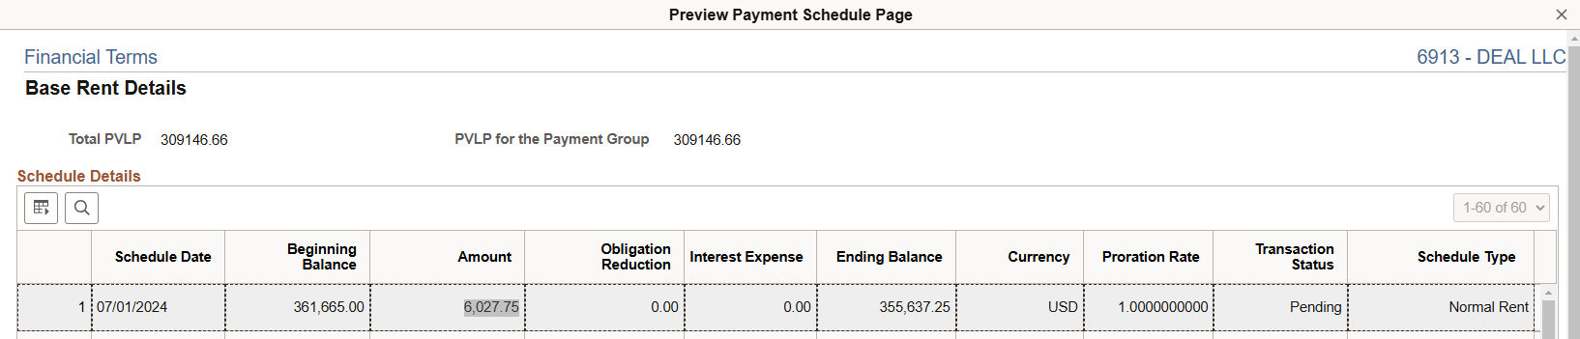

It is easier to find the amounts allocated to the fund/org/sub-class/project level in the lease query MTLA_LEASE_MODIFIED_ENTRY (generating results of the modified accrual entry amount), NewLeaseModifiedFundEntryAmt column. This query provides agencies with the allocated amounts if agencies have multiple governmental funds shared in one lease. The query parameters and the result are shown as below.

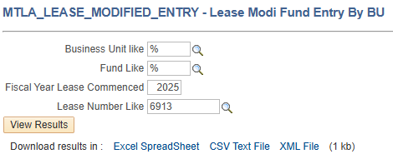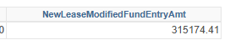

This one-time GL entries in both the ACTUALS ledger and the ENTITYWIDE ledger for the example lease in the commencement year are below. Each account in both ledgers combined should be zero. For SBITA, use 63409 and 583301.

Ledger | Fund | Account | Account Description | Debit | Credit
ACTUALS | 01100 | 63410 | NB Lease Commence Gov Fund | 315,174.41
ACTUALS | 01100 | 583300 | Inception of Lease-NONBUDGETED |  | 315,174.41

Ledger | Fund | Account | Account Description | Debit | Credit
ENTITYWIDE | 01100 | 583300 | Inception of Lease-NONBUDGETED | 315,174.41
ENTITYWIDE | 01100 | 63410 | NB Lease Commence Gov Fund |  | 315,174.41

Monthly amortization: AM generates these monthly amortization entries (DPR or PDP) at each month’s end for the amortization of the lease asset. They can be seen in the AM module and the GL module on the first day of the following month. Agencies do not make manual GL entries unless agencies identify errors in the system-generated entries.
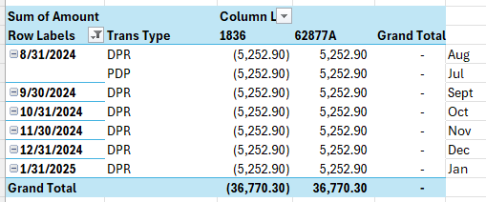

An example of the monthly amortization AM entry. 62877B is used for SBITA amortization.
The use of a ledger depends on the fund type (ENTITYWIDE ledger for governmental fund or ACTUALS ledger for proprietary fund.
Fund | Account | Account Description | Debit | Credit
01100 | 62877A | NB Lease Amortization | 5,252.90
01100 | 1836 | Accum Amort Intang Right Bldg |  | 5,252.90

The summarized total amortization of the example lease for FY25 is as below.
The use of a ledger depends on the fund type (ENTITYWIDE ledger for governmental fund or ACTUALS ledger for proprietary fund.
Fund | Account | Account Description | Debit | Credit
01100 | 62877A | NB Lease Amortization | 63,034.80
01100 | 1836 | Accum Amort Intang Right Bldg |  | 63,034.80

Monthly principal reduction: AM generates these monthly principal reduction entries (LPY or PLP) at each month’s end for the lease liability. They can be seen in the AM module and the GL module on the first day of the following month. Agencies do not make manual GL entries unless agencies identify errors in the system-generated entries.
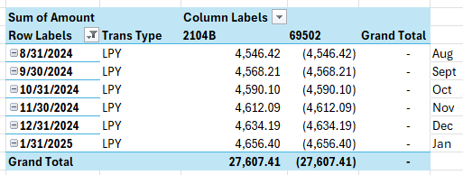

An example of the monthly principal reduction AM entry. 2104F and 69602 are used for SBITA principal reduction. Noting these entry amounts in 69502 are true principal reductions.
The use of a ledger depends on the fund type (ENTITYWIDE ledger for governmental fund or ACTUALS ledger for proprietary fund.
Fund | Account | Account Description | Debit | Credit
01100 | 2104B | Standard Lease | 4,546.42
01100 | 69502 | NB ROU Lease Principal |  | 4,546.42

The summarized total principal reduction of the example lease for FY25 is as below.
The use of a ledger depends on the fund type (ENTITYWIDE ledger for governmental fund or ACTUALS ledger for proprietary fund.
Fund | Account | Account Description | Debit | Credit
01100 | 2104B | Standard Lease | 57,253.97
01100 | 69502 | NB ROU Lease Principal |  | 57,253.97

Periodic lease payments: Agencies make initial direct cost payments, lease payments at or before the commencement date, or subsequent (to the lease commencement) lease payments (including both principal and interest) in the AP module (Accounts Payable WorkCenter).

In this example, the lease payment started on 7/1/2024, the commencement date, and should be accounted for in 69501 or 69601 because they are debt service payments to reduce the long-term debt resulting from the lease. Because the interest accounts are nonbudgeted accounts, for budgetary accounting purposes, 69501 or 69601 includes both true principal and true interest (total subsequent lease payment amount). If the voucher is coded to a different account, such as 62xxx, agencies need to make GL entries to reclassify the subsequent lease payments per the lease schedule to 69501 or 69601. If the payment amount is more than the lease payment scheduled, agencies need to compare it to the contract. Likely, the difference may be a non-lease component (62xxx) or a variable payment (62520 Variable Lease Exp or 62560 Variable SBITA Exp). Agencies need to identify and reclassify the difference to appropriate accounts. If the difference is the increase in the contract term and agencies will pay the new rates, agencies need to modify the lease.

Run the lease query MTLA_LEASE_PRINCIPAL_BU, and click Excel Spreadsheet to download the schedule. The amounts in Column 69501 or 69601 are the lease amounts that should be recorded in one of the two accounts depending on the lease type. They are allocated to the combination of fund/org/sub-class/project level. To look up leases in proprietary funds, use a business unit code that ends with a letter P, for example, 5102P.
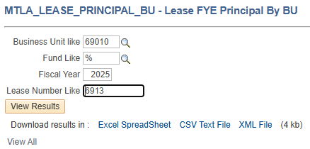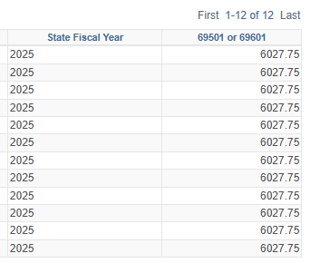

An example of the monthly subsequent lease payment AP ACC accrual entry.
Ledger | Fund | Account | Account Description | Debit | Credit
ACTUALS | 01100 | 69501 | ROU Lease Principal | 6,027.75
ACTUALS | 01100 | 2107 | Vouchers Payable |  | 6,027.75

The summarized total lease payment AP ACC accrual entry of the example lease for FY25 is as below.
Ledger | Fund | Account | Account Description | Debit | Credit
ACTUALS | 01100 | 69501 | ROU Lease Principal | 72,333.00
ACTUALS | 01100 | 2107 | Vouchers Payable |  | 72,333.00

FYE interest recording: Because interest account 69503 or 69603 is a non-budgeted account, both principal and interest are recorded in 69501 or 69601 for budgetary accounting. At fiscal year-end prior to the close of the GL module, agencies need to record fiscal year-end interest entries, based on the lease schedules, which will reclassify the portion of interest to 69503 or 69603. The interest is part of the lease payment so it must be recorded in the ACTUALS ledger.

The interest amount can be found in the lease query MTLA_LEASE_FYE_INTEREST_BU. The Fiscal Year as a parameter is the fiscal year to be reclassified. For example, at FY25 FYE, agencies need to reclassify the FY25 interests, so enter 2025 as the Fiscal Year. Download the Excel Spreadsheet. The amounts in Column 69503 or 69603 are the lease interest amounts that should be recorded in one of the two accounts depending on the lease type. They are allocated to the combination of fund/org/sub-class/project level. To look up leases in proprietary funds, use a business unit code that ends with a letter P, for example, 5102P.
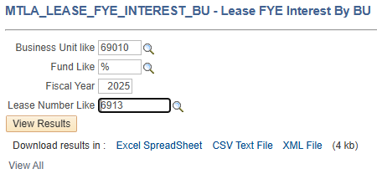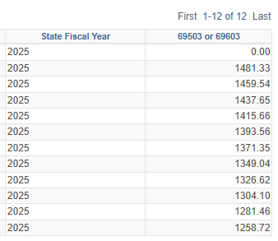

Below is an example of the summarized interest reclassification entry for FY25. For SBITA, use 69603 and 69602.
Ledger | Fund | Account | Account Description | Debit | Credit
ACTUALS | 01100 | 69503 | ROU NB Lease Interest | 15,079.03
ACTUALS | 01100 | 69502 | NB ROU Lease Principal |  | 15,079.03

FYE current portion of lease liability reclassification: the initial lease liability and subsequent principal reduction are only recorded in 2104B or 2104F, depending on the lease type, the long-term portion of the lease payable. At fiscal year-end prior to the close of the GL module, agencies need to reclassify the current portion, due within one year from the current fiscal year-end date, to 2124B or 2124F. The amount of the current portion can be found in the initial lease schedule if no change has been made to the lease subsequently or use the lease query MTLA_LEASE_FYE_CVSNC_BU. The Fiscal Year as a parameter is the following fiscal year. For example, at FY25 FYE, agencies need to reclassify the current portion for FY26, so enter 2026 as the Fiscal Year. Download the Excel Spreadsheet. The entry amounts are in the Fund Obligatio Reduction 2124x column. To look up leases in proprietary funds, use a business unit code that ends with a letter P, for example, 5102P.
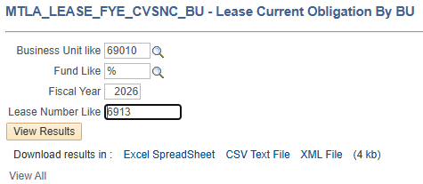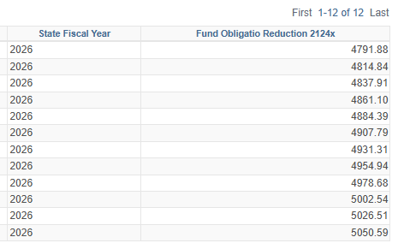

Below is an example of the summarized current portion of the lease liability reclassification entry. For SBITA, use 2104F and 2124F. This entry needs to be reversed on 7/1.
The use of a ledger depends on the fund type (ENTITYWIDE ledger for governmental fund or ACTUALS ledger for proprietary fund.
Fund | Account | Account Description | Debit | Credit
01100 | 2104B | Standard Lease | 59,042.48
01100 | 2124B | Standard Lease - Due W/in 1 Yr |  | 59,042.48

Recap: After the FYE interest reclassification entry and the FYE current portion of lease liability reclassification entry, agencies should see account balances in the fund trial balance for FY25 for the example lease below:

Ledger | Fund | Account | Account Description | Balance | Explanation
ENTITYWIDE | 01100 | 1832 | Intangible Right to Use Bldg | 315,174.41 | The cost of lease asset generated by AM
ENTITYWIDE |  | 1836 | Accum Amort Intang Right Bldg | -63,034.80 | 12 months of amortization generated by AM
ENTITYWIDE |  | 2104B | Standard Lease | -198,877.96 | The noncurrent portion of lease liability
ENTITYWIDE |  | 2124B | Standard Lease - Due W/in 1 Yr | -59,042.48 | The current portion of the lease liability
ENTITYWIDE |  | 62877A | NB Lease Amortization | 63,034.80 | 6 months amortization expense generated by AM
ENTITYWIDE |  | 583300 | Inception of Lease-NONBUDGETED | 315,174.41 | Modified fund entry for a new lease
ENTITYWIDE |  | 63410 | NB Lease Commence Gov Fund | -315,174.41 | Modified fund entry for a new lease
ENTITYWIDE |  | 69502 |  | -57,253.97 | Total fund obligation reduction in FY24
ACTUALS | 01100 | 583300 | Inception of Lease-NONBUDGETED | -315,174.41 | Modified fund entry for a new lease
ACTUALS |  | 63410 | NB Lease Commence Gov Fund | 315,174.41 | Modified fund entry for a new lease
ACTUALS |  | 69501 | ROU Lease Principal | 72,333.00 | The total future lease payments including principal and interest for the budgetary purpose
ACTUALS |  | 69502 | NB ROU Lease Principal | -15,079.03 | Interest offset, net with 69501 in the ACTUALS ledger equals (51,226.22) the true principal amount per schedule, and also equals 69502 in the ENTITYWIDE ledger
ACTUALS |  | 69503 | ROU NB Lease Interest | 15,079.03 | NB interest expense per schedule
ACTUALS |  | 1104  or  2107 | Cash In Bank  or  Vouchers Payable | -72,333.00 | The total of all lease payments
Note: the lease query further allocates lease amount, principal, and interest to the fund/org/sub-class/project level, it’s normal to see rounding differences between the lease query schedule and the entries in AM.

The goal for the account balance in 695xx, 58330x, and 63xxx:
69501: always in the ACTUALS ledger that matches the total lease amount (principal and interest) per schedule. If not, maybe variable payments or other coding errors, etc
69503: always in the ACTUALS ledger that matches the interest per schedule
69502: in the ACTUALS ledger that offsets with 69503
69502: in the ENTITYWIDE ledger that matches the true principals, or equals the balance in 69501 subtracting the balance in 69503
58330x: always a credit in the ACTUALS ledger and a debit in the ENTITYWIDE ledgers, net to $0
63xxx: always a debit in the ACTUALS ledger and a credit ENTITYWIDE ledgers, net to $0

Lease retirement: When agencies retire leases, AM will generate a RET entry to remove the book value of the retired lease asset and if retired early, remove any unpaid lease liability. Agencies need to review the Financial Entries in AM and make GL clean-up entries based on the real situation. Common clean-up entries include:
- No gain or loss should be recognized but AM generates gain or loss, agencies need to reverse the gain or loss.
- Because of the timing of retiring a lease, the system may generate amortization and accumulated amortization reversal in the month of retirement, then generate the lease asset retirement with a loss. If the lease is terminated in full term, no loss should be recorded. Agencies need to reverse the loss and the amortization reversal to restore the true amortization expense over the life of the lease.

Other lease query:
Agencies may use this lease query
MTLA_LEASE_PAYABLE_BAL_BU to verify the lease liabilities at FYE. This query is to show the total lease liability including current and noncurrent portion for a lease at FYE. The sum of the GL balances in 2104x and 2124x should match the total of lease liabilities per the query schedule within only a rounding difference between the lease schedule and GL/AM account balances. To look up leases in proprietary funds, use a business unit code that ends with a letter P, for example, 5102P.
