Accounts Payable (AP) Work Center
- Designed to be a “one stop shop” for AP users.
- Access AP Work Center:
  - SABHRS Accounts Payable tile
or
  - Classic Home tile - Main Menu > Accounts Payable > Accounts Payable WorkCenter
- SABHRS roles and permissions allows users access to My Work, Links, Queries, and Reports/Processes pagelet links.

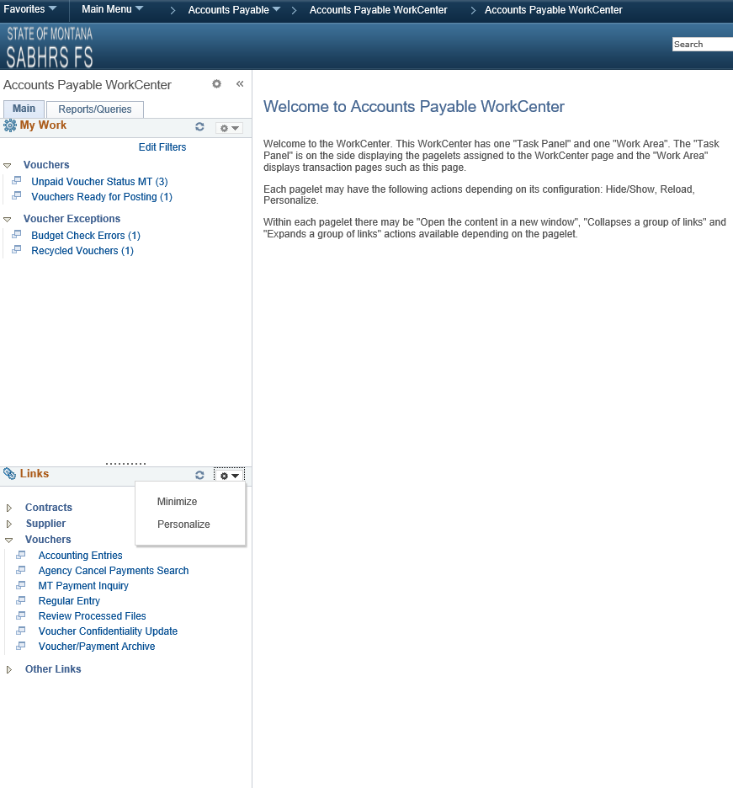
Links: Includes links to AP pages and other areas of interest including external links and references. Links are grouped and collapsed. Click on arrows to expand groups or users can personalize group(s) to be expanded.
My Work: Includes links to current work and exceptions. These are queries that refresh upon opening this page or clicking the refresh button.
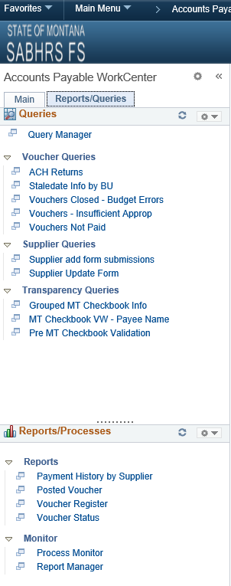
Reports/Processes: Includes links to common AP reports, as well as, the Process Monitor and Report Manager.
Queries: Includes links to commonly used public queries.

Accounts Payable (AP) Work Center
- AP Work Center, My Work items views are the same for the AP roles: AP – Claims Clerk, (FS01) and AP – Voucher Approving Officer (FS02).
  - SABHRS roles and permissions allows users access to the appropriate pages for their specific job responsibilities/activities.
- Users cannot only view transactions that need attention but can take action from the Work Center (approve, delete, etc.).

My Work Section:
- Click on each My Work item hyperlinks to view transactions that need attention.
  - If there are no transactions that need attention for the BU’s selected in Edit Filters, there will not be a hyperlink on the work item(s).
- Voucher ID hyperlink opens new tab with the voucher.
- Supplier ID hyperlink opens new tab with the supplier.
- Users can go into the Personalize link to personalize column and sort order. Columns can also be sorted by clicking on column header.

Unpaid Voucher Status MT - unpaid vouchers.
- Approval Status – Pending/Denied hyperlinks opens the Voucher Approval screen for FS02 users. FS01 users will receive a not authorized message.
  - Vouchers with Recycle status cannot be approved; therefore, the Pending hyperlink opens to the Voucher Approval search screen.

- Vouchers that are saved with the Save For Later button will not have a Scheduled Pay Date plus the Pending Approval link will take FS02 users to the Voucher Approval search page as the voucher is not ready for Approval.

Vouchers Ready for Posting – cancelled vouchers and vouchers that are Approved and have a Valid Budget Check Status will process during the nightly BATCH processing.

Budget Check Errors - vouchers with budgets errors.
- Exceptions links opens the Voucher Exception window so users can review budget exceptions.

Recycled Vouchers - duplicate vouchers (BU, Invoice Number, Invoice Date, and Gross Amount are all the same for another voucher) or voucher with incorrect chartfield information.
- Voucher ID hyperlink takes the user to the Error Summary page of the voucher. Page displays a message as to why the voucher is in Recycle Status.

- Delete icon opens Voucher Delete window for FS02 users. FS01 users will receive a not authorized message.
Edit Filters:
- Users can change their filters by clicking on “Edit Filters”.
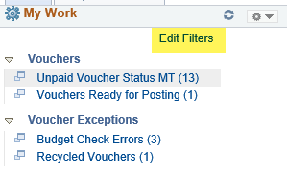

- Click on View All to access all My Work Groups – My Work Links.
- Click on the Edit Filters icon for the work item to be changed.

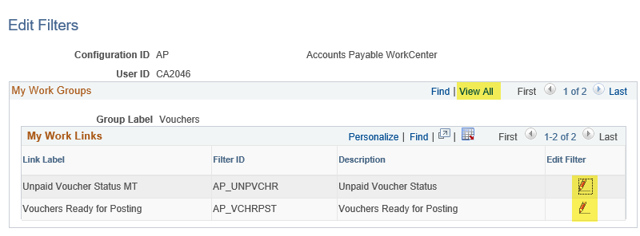

Edit Filters:
- Prepopulated: Created On >= 07/01/2018, Invoice Date >= 07/01/2018, and users default AP BU’s (excluding BU’s 5801Z 6104Z, 6105Y, 6602Y, 6901S, 6901W, and 6901X due to performances issues).
  - Recommend using Refine Search Criteria to select excluded BU’s as there may be performance issues including them in Edit Filters.
  - Excluded BU’s can be selected in Edit Filters once AP Work Center has been accessed multiple times.
    - BU and Create On are required fields for Unpaid Voucher Status MT.
    - BU, Create On, and Invoice Date are required fields for Vouchers Ready for Posting, Budget Check Errors, and Recycled Vouchers.
- Users can use the magnify glass to select field values or they can enter them manually:
  - Users can select or enter one or all default AP BU’s.
    - Entered BU’s and Created BY require upper case letters.
    - Enter BU’s and Created BY as follows: 54010,5401S,5401Z / CA2046,CMA160. Do not put a space after comma.
    - Enter Created BY - Description (user name):
      - Search using = - can use lower or upper letters for all letters.
      - Search using in - have to enter upper case letter for first letter of first and/or last name.

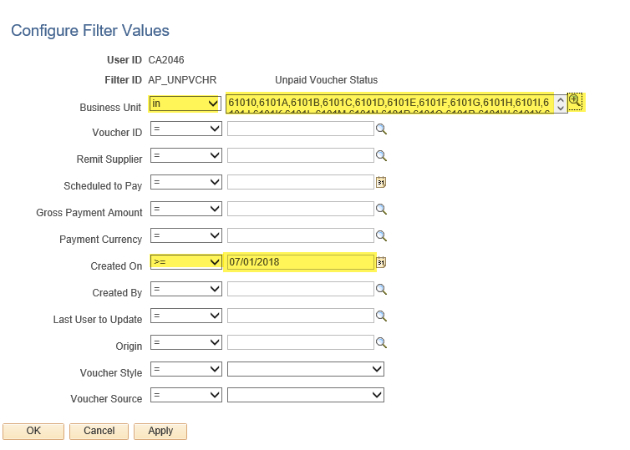
- Click Apply and OK.
Edit Filters:
- Refresh the pagelet to see your changes.
  - Click on the refresh icon to reload My Work.

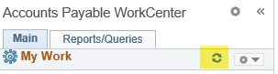

Refine Search Criteria:
- Use Refine Search Criteria to temporarily narrow the search results – refined results will revert to the saved filters the next time the link is used.

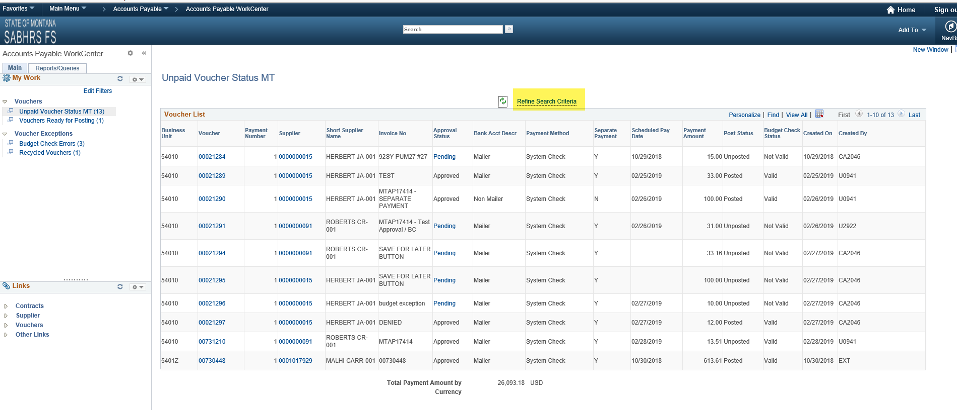
Refine Search Criteria:
- Populates with Edit Filters filter values.
  - Recommend using Refine Search Criteria to select excluded BU’s as there may be performance issues including them in Edit Filters.
  - Excluded BU’s can be selected in Edit Filters once AP Work Center has been accessed multiple times.
    - BU and Create On are required fields for Unpaid Voucher Status MT
  - BU, Create On, and Invoice Date are required fields for Vouchers Ready for Posting, Budget Check Errors, and Recycled Vouchers
- Users can use the magnify glass to select field values or they can enter them manually:
  - Users can select or enter one or all default AP BU’s.
    - Entered BU’s and Created BY require upper case letters.
    - Enter BU’s and Created BY as follows: 54010,5401S,5401Z / CA2046,CMA160. Do not put a space after comma.
    - Enter Created BY - Description (user name):
      - Search using = - can use lower or upper letters for all letters.
      - Search using in - have to enter upper case letter for first letter of first and/or last name.

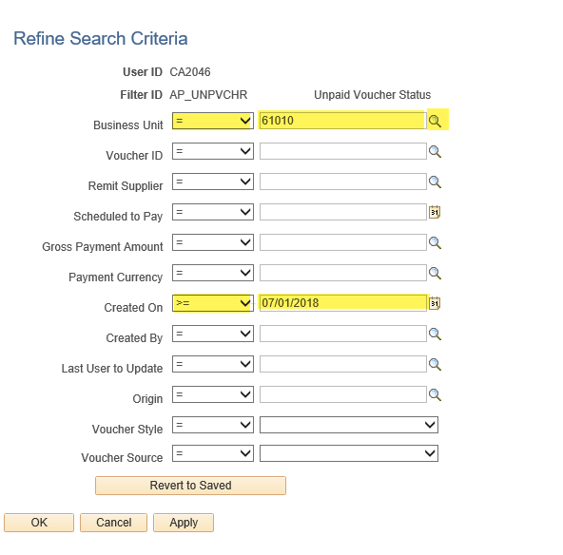
- Click Apply and OK.
Personalize Pagelets:
- Users can personalize each pagelet.
  - Click the down arrow across from the pagelet name then select “Personalize”.

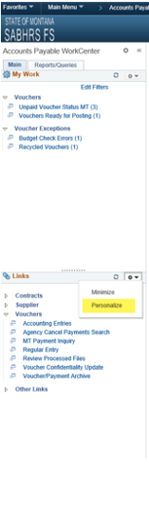
Pagelets

Personalize Pagelets:
- Users can collapse/expand group of links, display order, show/hide links, and/or open the content in a new window.
- Click on View All to access all items in the pagelet.
- Click Save if changes are made.

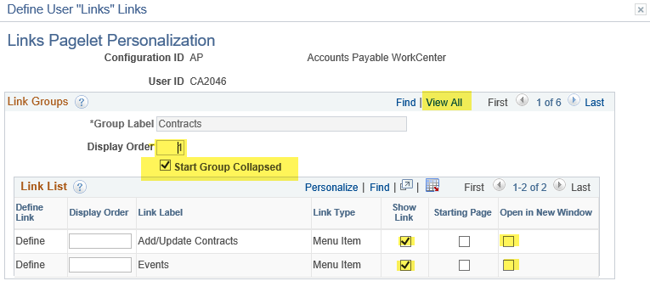

Refresh the pagelet to see your changes.
- Click on the refresh icon to reload My Work, Links, Queries, or Reports/Processes pagelets.

Personalize Pagelets:
- Users can delete pagelet(s) personalization.

